1.Abstract

The Lost and Found Intelligence System is a database-driven application proposed to help users report, search, and manage lost and found belongings in an organized manner. People may misplace items such as identity cards, books, wallets, mobile phones, bags, keys, and electronic devices. Traditional methods, including verbal communication, paper registers, announcements, and notice boards, can make it difficult to maintain accurate records and connect an item with its owner.
The system uses Core Java for application logic, MySQL for persistent data storage, and Java Database Connectivity (JDBC) to communicate with the database. Users can register or log in, report lost items, register found items, and search stored records using details such as item name, category, description, colour, location, and date. An item-matching function compares details from lost and found reports to identify possible matches. A claim process can support ownership verification, while administrative functions can be used to manage records, review claims, and update item statuses.
By maintaining information in a centralized database, the system aims to reduce manual effort, improve record organization, and make it easier to recover misplaced belongings. The project also demonstrates the practical use of Java programming, object-oriented programming concepts, SQL, JDBC connectivity, exception handling, and database design. Matching accuracy depends on the rules implemented and the quality of information entered by users.

2.Introduction
The Lost and Found Management System is a database-based application developed to manage lost and found items within a college, organization, or institution. In colleges, students and staff may frequently lose personal belongings such as ID cards, books, wallets, mobile phones, bags, keys, and other valuable items. At the same time, people who find these items may not know how to return them to their owners. Traditional methods such as notice boards, announcements, and manual registers can make the process difficult and time-consuming.
The proposed system provides a centralized platform where users can report lost items and register items they have found. Each record contains important information such as item name, category, description, location, date, and current status. Users can search the database to find possible matches for their lost belongings. The system can also compare details of lost and found items to identify potential matches.
The system uses Java for application development, MySQL for database management, and JDBC for connecting the Java application with the database. The database stores user information, lost item records, found item records, matching details, and claim information in an organized manner.
An admin module is provided to manage records, verify claims, update item status, and maintain the overall system. The status of an item can be updated as Lost, Found, Matched, Claimed, or Returned, allowing users and administrators to track the progress of each item.
The main objective of the system is to make the lost and found process faster, organized, and easier to manage. By using a centralized database, the system reduces manual record keeping and provides an efficient way for users to search, match, and recover lost belongings.

3.Problem Statement and Objectives

Problem Statement

The current manual process of handling lost and found belongings is often time-consuming and difficult to track. Reports may be incomplete, duplicated, or overlooked, and people who find items may have difficulty contacting the rightful owners. There is a need for a centralized, database-based application that can store reports, search records, compare item details, manage claims, and allow authorized administrators to maintain accurate statuses.

Objectives

- Develop a centralized Lost and Found management application for a college or organization.
- Allow users to report lost items and register found items.
- Store item details such as name, category, description, colour, location, date, and contact information.
- Provide searching and filtering by item name, category, location, date, or keywords.
- Compare important attributes of lost and found items to identify possible matches.
- Provide notifications or alerts for potential matches and status changes.
- Support claims and ownership verification for found items.
- Provide administrator functions to manage users, reports, claims, and item statuses.
- Maintain structured and persistent records using MySQL and JDBC.
- Reduce manual record keeping and improve the efficiency of the recovery process.

4.Scope of Project

The scope of the Lost and Found Intelligence System includes user account handling, lost-item reporting, found-item reporting, searching and filtering, matching of item records, claim handling, notifications where implemented, and administrative management. A user can enter details such as the name of the item, its description, category, colour, place and date of loss or discovery, and relevant contact information. The application can save and retrieve these details through the MySQL database.
The matching module can compare selected attributes from lost and found records and display candidate matches for further review. The claim process can record a user's request to recover an item, while an administrator can review the request and update its status according to the implemented workflow. The system is intended for a defined group or organization and can be adapted for a campus, office, library, or similar environment.
The system has limitations. Matching quality depends on how accurately users describe items and on the comparison rules used in the application. A match is only a possible connection and does not prove ownership. Human or administrator verification remains important before returning valuable belongings. Email, SMS, image recognition, mobile access, and machine-learning features are future possibilities unless separately implemented and tested.

5.Software and Hardware Requirements

Software Requirements

Software / Technology | Purpose
Java Development Kit (JDK) | Compiles and runs the Java application.
Core Java | Implements application logic, classes, collections, validation, and exception handling.
MySQL Server | Stores user, item, match, claim, and notification records.
MySQL version 8.4 or another SQL client (optional) | Creates tables and helps inspect and manage the database.
JDBC driver for MySQL | Enables Java-to-MySQL connectivity.
Java IDE (e.g., Eclipse, IntelliJ IDEA, or NetBeans, Spring Tool) | Used to write, debug, compile, and execute Java code.
Operating system (Windows/Linux) | Provides the environment to develop and run the application.

Hardware Requirements
Component | Minimum / Suggested Requirement
Processor | A modern dual-core processor or better
RAM | 4 GB minimum; 8 GB recommended for comfortable development
Storage | At least 1 GB of free space for tools and project files, plus database storage
Network | Useful for downloading tools; local execution can use a local MySQL server

6.System Architecture and Module Description

System Architecture

The system follows a simple three-layer logical architecture: the user interface, application/business logic, and database layer. In the proposed console-based version, users interact through a text menu. Java classes validate inputs and apply the rules for searching, matching, claims, and administration. JDBC sends SQL commands to MySQL and returns query results to the Java application.
Layer | Main Responsibilities
Presentation Layer | Displays menus and prompts; accepts login, report, search, and claim details.
Application / Business Logic Layer | Validates input, applies role permissions, performs search and matching, manages claims, and controls item status.
Database Layer | Stores and retrieves users, lost items, found items, categories, matches, claims, and notifications through MySQL.

Module Description

Module | Description
1. Login / Registration Module | Allows students, staff, and administrators to register and securely log in to the system. Role-based access is provided according to the user's role.
2. User  Module | Allows users to manage their profile, report lost or found items, view their submitted reports, and check notifications.

3. Admin Module | Allows the administrator to manage users, view reports, verify claims, and update the status of lost and found items.
4. Lost /Found Item Module | Allows users to enter item details such as item name, category, description, color, location, date, and image, and store the information in the database
5. Search Module | Allows users to search for items using item name, category, location, and date. It also displays relevant matching results.
6. Intelligent Matching Module | Compares the details of lost and found items and identifies possible matches based on common attributes such as name, category, color, location, and date.
7. Claim Module | Allows users to submit a claim for a found item and provide verification details. The claim status can be tracked until the admin completes verification
8. Notification Module | Notifies users when a possible match is identified and displays important alerts or status updates.
9. Performance / Report Module | Maintains item history and generates reports related to lost, found, matched, claimed, and returned items.
10. Database Module | Stores and manages user details, lost and found item records, claims, notifications, and other system information using MySQL through JDBC.

7.Database Design
MySQL is used as the relational database management system for the Lost and Found Intelligence System. It stores user details, lost-item reports, and found-item reports. Primary keys uniquely identify records, while foreign keys establish relationships between tables. The database supports user authentication, item reporting, status updates, and intelligent matching of lost and found items.
1.Proposed Table:
Table | Important Fields | Purpose
Users | user_id (PK), name, email, password, role | Stores user and administrator account details.
Lost_Items | item_id (PK), item_name, description, location, date_lost, status, user_id (FK) | Stores information about items reported as lost.
Found_Items | item_id (PK), item_name, description, location, date_found, status, user_id (FK) | Stores information about items reported as found.
User Table:
Field | Data Type | Description
user_id | INT | Primary key; auto-increment
name | VARCHAR(100) | Name of the user
email | VARCHAR(150) | Unique email address
password | VARCHAR(255) | User password storage
role | VARCHAR(20) | Identifies USER or ADMIN
Lost_Items_Table:
Field | Data Type | Description
item_id | INT | Primary key
item_name | VARCHAR(100) | Name of the lost item
description | TEXT | Details of the item
location | VARCHAR(255) | Location where the item was lost
date_lost | DATE | Date the item was lost
status | VARCHAR(30) | Current status of the lost item
user_id | INT | Foreign key referencing Users

Found_Items_Table:
Field | Data Type | Description
item_id | INT | Primary key
item_name | VARCHAR(100) | Name of the found item
description | TEXT | Details of the item
location | VARCHAR(255) | Location where the item was found
date_found | DATE | Date the item was found
status | VARCHAR(30) | Current status of the found item
user_id | INT | Foreign key referencing Users

2. Relationships
- One user can report multiple lost items.
- One user can report multiple found items.
- Each lost-item record is associated with the user who reported it.
- Each found-item record is associated with the user who reported it.
- The role field distinguishes normal users (USER) from administrators (ADMIN).
- The system can compare item names, descriptions, and locations to identify potential matches between lost and found records.
- Item statuses can be updated as the item moves through the reporting, matching, and return process.

8.Java Class Design and Object-Oriented Programming Concepts
Class | Responsibility
User | Represents common account information such as user ID, name, email, phone, and role.
Student / Staff | Can extend User when separate role-specific classes are useful.
Admin | Represents administrator actions such as reviewing claims and managing records; may extend User.
LostItem | Represents a lost-item report and its attributes.
FoundItem | Represents a found-item report and its attributes.
Category | Represents a category of belongings.
Match | Stores the relationship and matching details between a lost item and a found item.
Claim | Stores claimant details, verification information, and claim status.
Notification | Represents an alert or status update for a user.
DatabaseConnection | Creates and manages JDBC connections to MySQL.
UserService / ItemService | Contains application operations such as registration, login, report submission, and search.
MatchingService | Compares lost and found item attributes using the implemented matching rules.
ClaimService | Submits claims and supports administrator review.
Main / Menu | Starts the console application and routes user choices to the appropriate services.

Object-Oriented Programming Concepts

Class and Object
A class defines the structure and behaviour of an entity, while an object is an instance of that class. For example, LostItem is a class, and a particular report for a missing blue bag is an object.

Encapsulation
Data members should generally be private and accessed through public methods. This helps control how user and item data is read or modified.

Inheritance
Common account properties can be defined in a User class and inherited by Student, Staff, or Admin classes if that class structure is used in the implementation.

Polymorphism
A common method or interface can have different implementations for different user roles or service types. For example, role-specific actions may be implemented by overriding a method or by using separate service methods.

Abstraction
The application can expose simple operations such as reportLostItem() or searchItems() while hiding database and validation details inside service classes.

Constructors
Constructors initialize objects with required information, such as an item name, category, location, and date.

Exception Handling
try-catch blocks can handle invalid input, SQL errors, and connection failures. Error messages should help users recover without exposing passwords or sensitive technical details.

Collections
ArrayList can hold lists of search results, and HashMap can associate identifiers with objects or attributes when useful. Collections are temporary application data structures

JDBC
JDBC allows Java to connect to MySQL, execute prepared SQL statements, retrieve query results, and perform insert, select, update, and delete operations. PreparedStatement should be preferred for user-supplied values.

9.Testing and Test Cases
Testing checks whether the application behaves as expected for valid and invalid inputs. The following test cases are suggested for the planned functions. Fill in the Actual Result and Status columns after executing the corresponding tests in the working application.
TC ID | Test Scenario | Test Input / Action | Expected Result | Actual Result / Status
TC01 | User registration with valid details | Enter valid name, email, password, and role | Account is created and stored in MySQL | To be filled after testing
TC02 | Duplicate email registration | Register using an email already present | System rejects the duplicate account with a clear message | To be filled after testing
TC03 | Login with valid credentials | Enter a registered email and correct password | User is logged in and sees permitted menu options | To be filled after testing
TC04 | Login with invalid credentials | Enter an incorrect password | Login is rejected without exposing sensitive information | To be filled after testing
TC05 | Report a lost item | Enter valid item details and submit | Lost-item record is stored and can be retrieved | To be filled after testing
TC06 | Register a found item | Enter found-item details and submit | Found-item record is stored successfully | To be filled after testing
TC07 | Search by item name | Search for a known item name | Relevant records are displayed | To be filled after testing
TC08 | Search with no match | Search for an item that is not recorded | System displays a suitable no-results message | To be filled after testing
TC09 | Potential match detection | Create lost and found records with matching attributes | System identifies a potential match according to implemented rules | To be filled after testing
TC10 | Submit a claim | Submit claim details for a found item | Claim is stored with an initial status | To be filled after testing
TC11 | Admin reviews claim | Admin approves or rejects a pending claim | Claim status and related item status update appropriately | To be filled after testing
TC12 | Unauthorized admin action | A non-admin user attempts an admin operation | Access is denied | To be filled after testing
TC13 | Database unavailable | Stop MySQL and attempt a database operation | Application handles the connection error gracefully | To be filled after testing

10.Output Screenshots and Results
1.For new user registration:
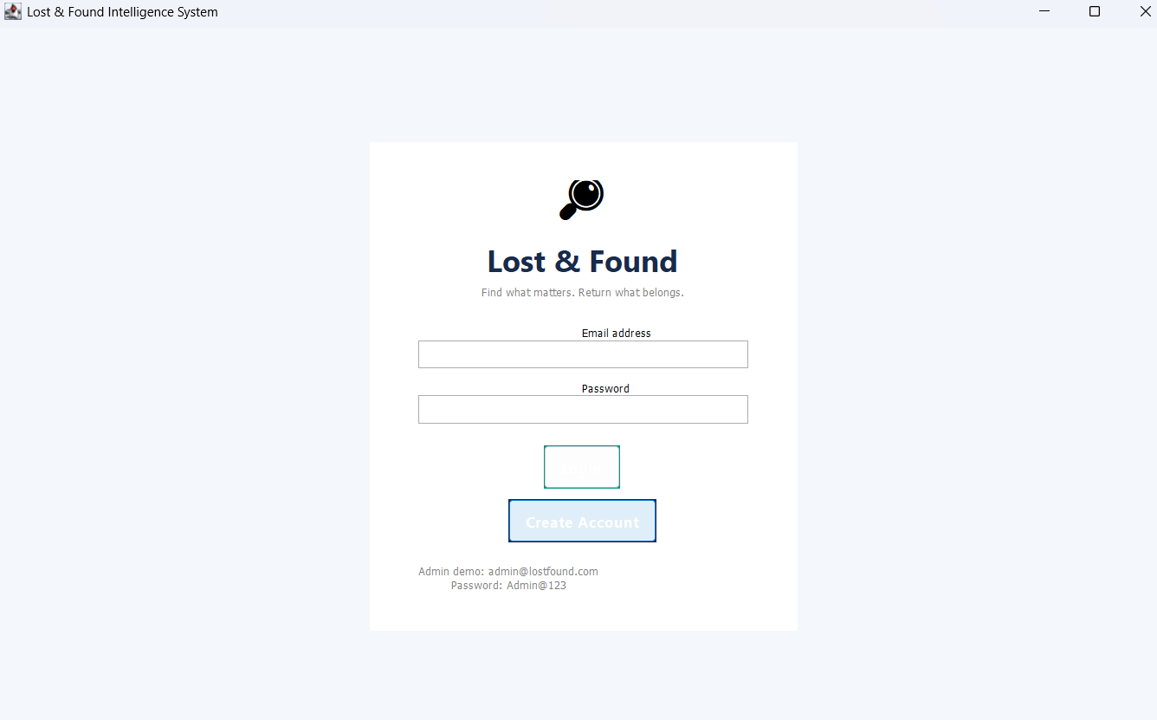
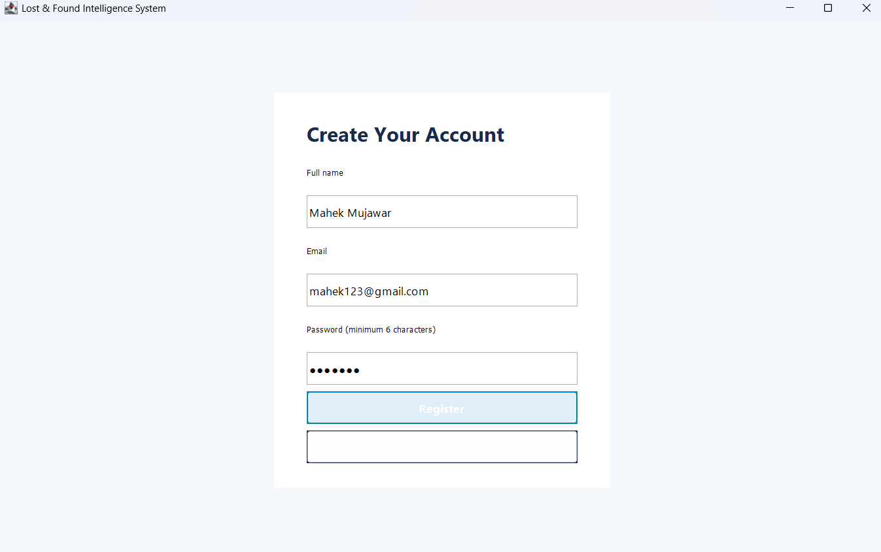
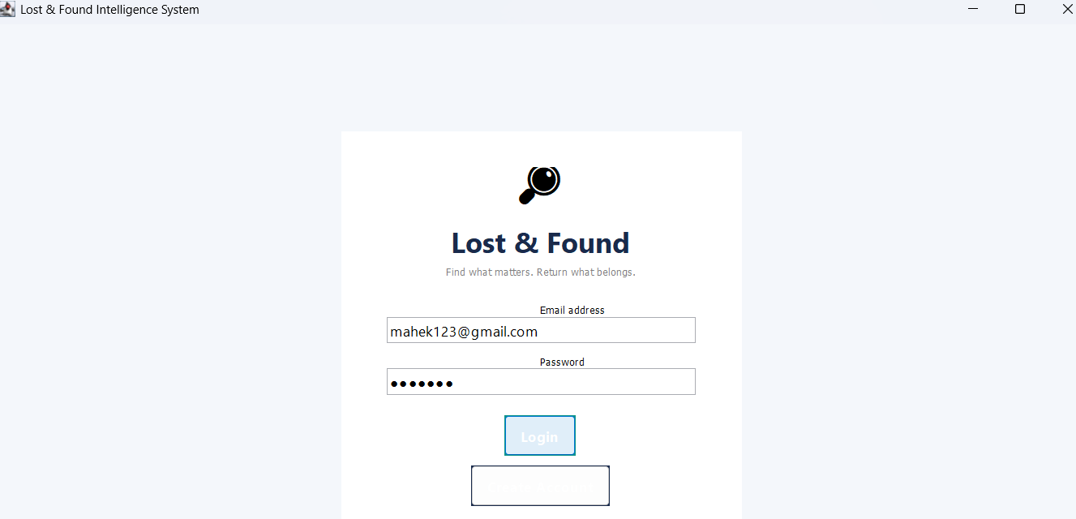

2. After Successful login of user:
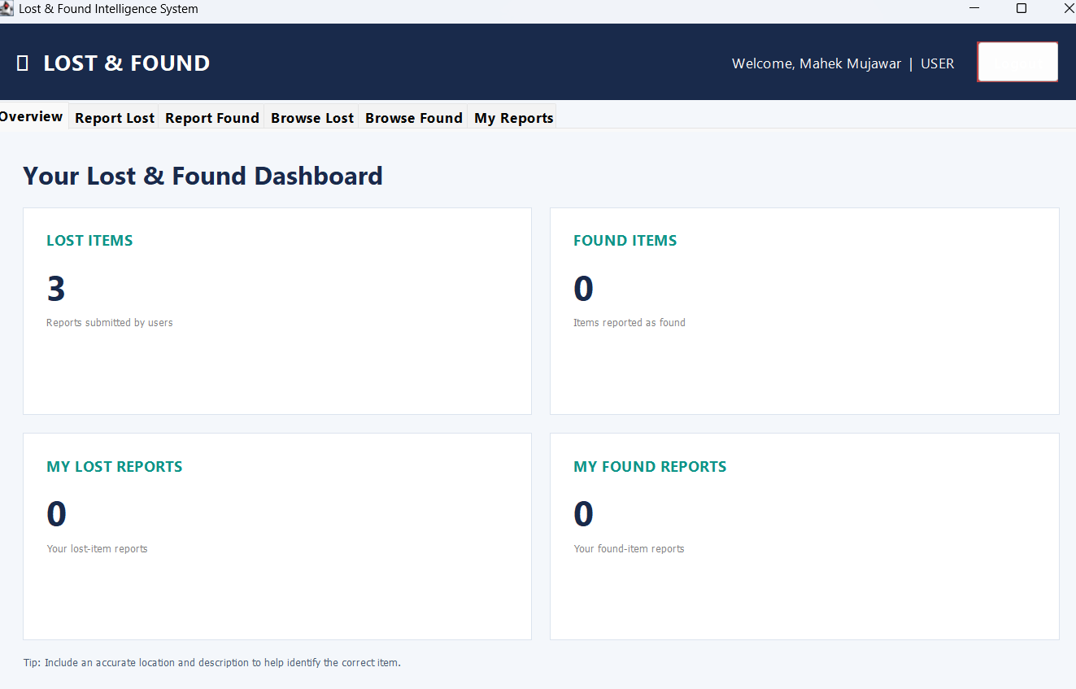
3.Report Lost item:
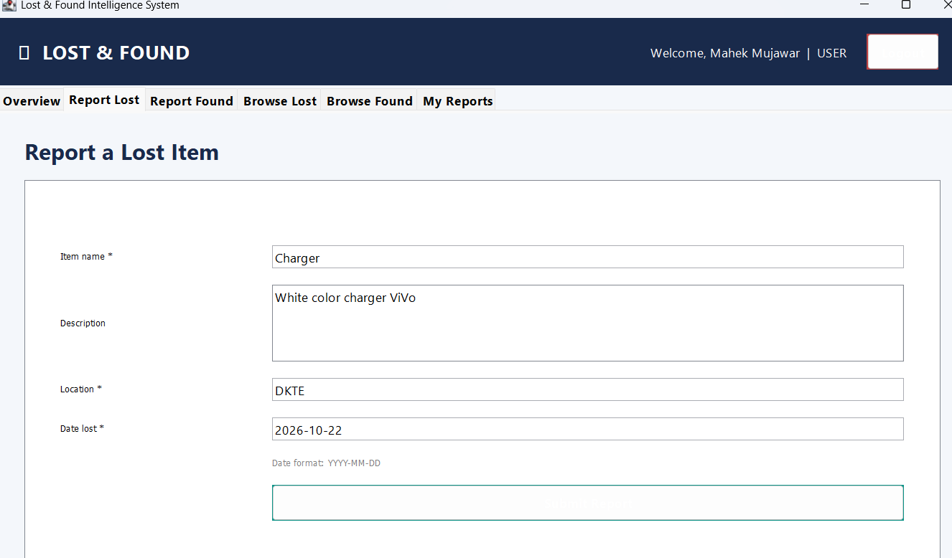
4.Report of found item:
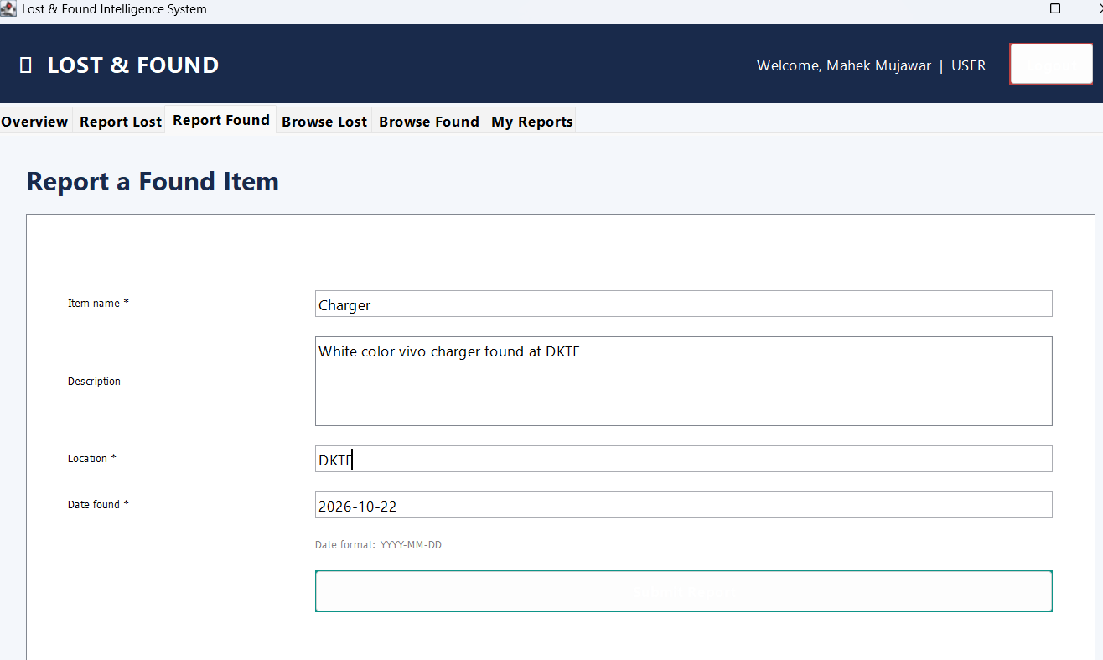
5.User’s Reports:
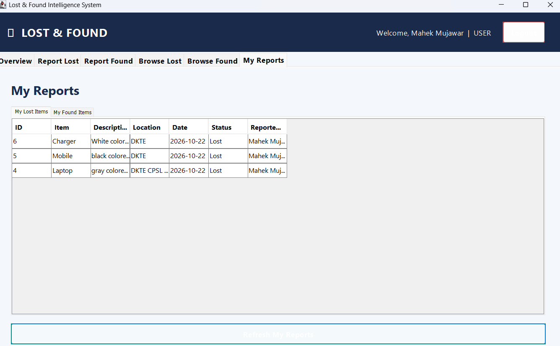
6. Admin login:
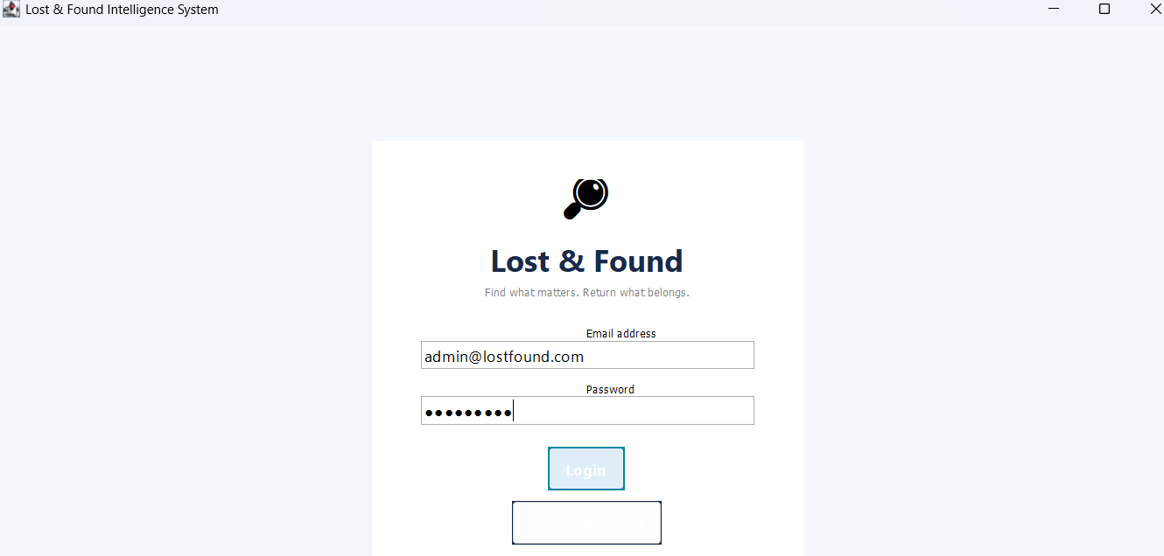
7.Status and reports Checking:
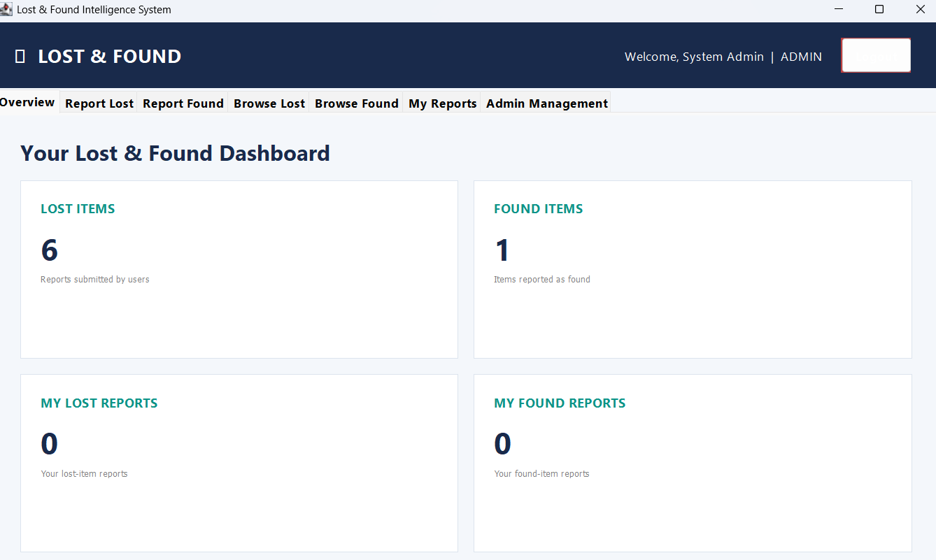
8. Admin Management:
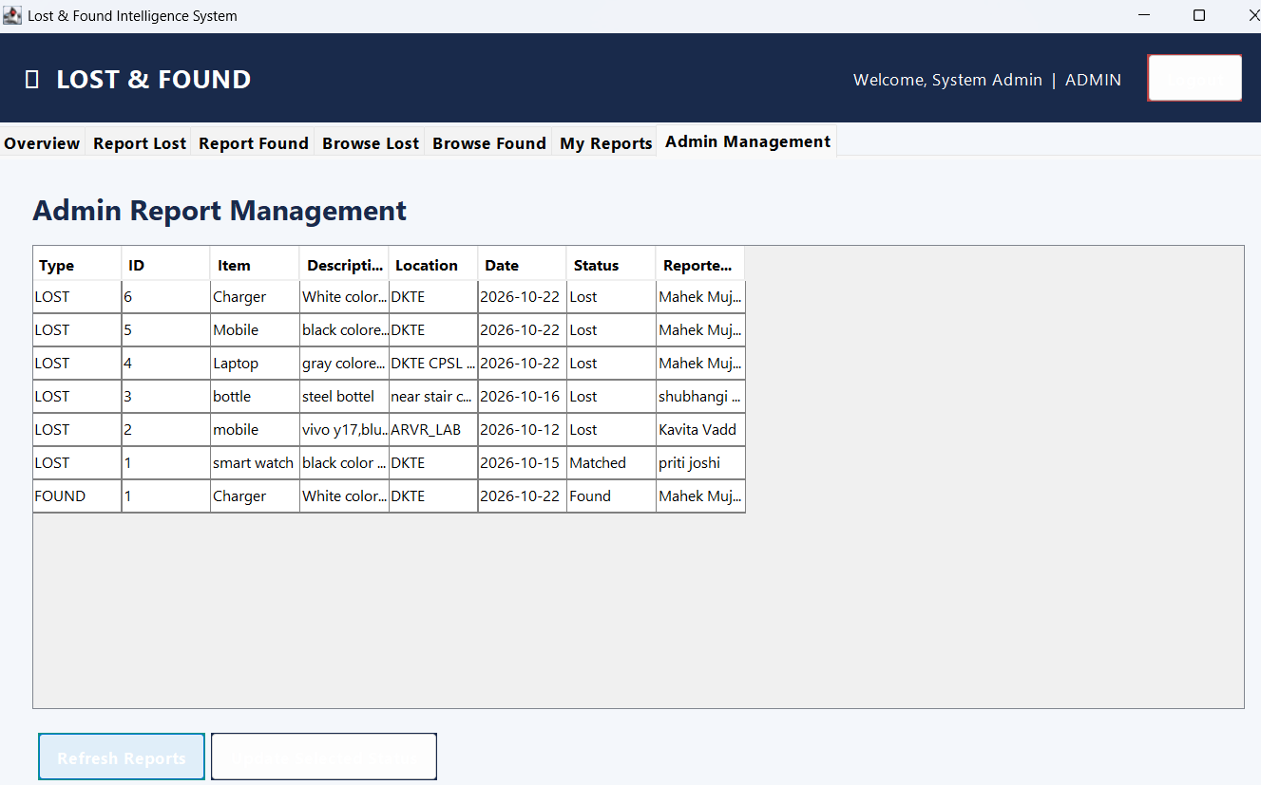
User Table:
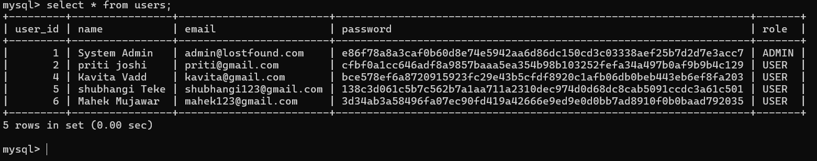
Lost_items Table:
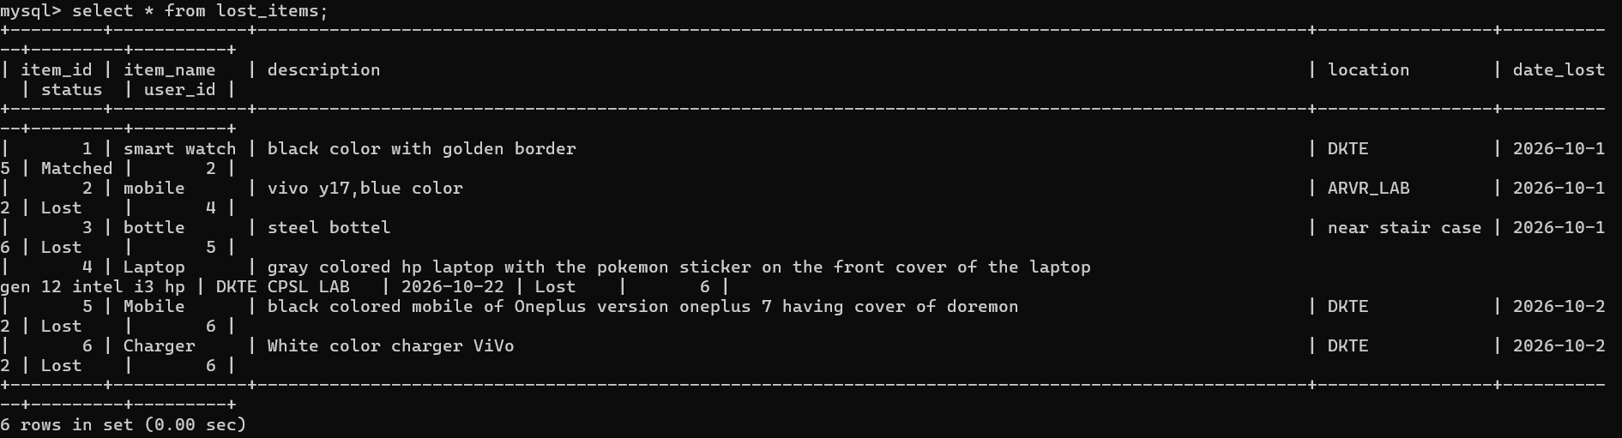
Found_items table:
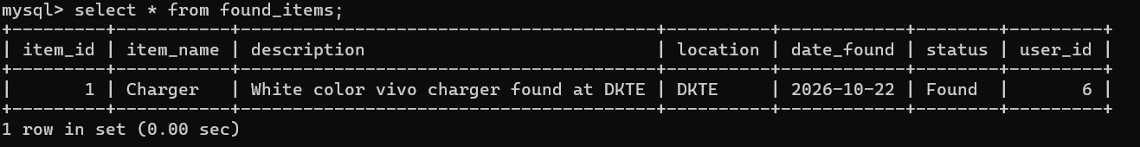

11.Conclusion and Future Enhancements

Conclusion

The Campus Lost and Found Intelligence System proposes an organized way to manage lost and found belongings within a college or organization. It replaces scattered notices and manual records with a centralized database that can store item reports, support searching, compare lost and found details, and maintain claim and status information. Java provides the application logic, MySQL provides persistent storage, and JDBC connects the application to the database.
The project brings together important programming concepts, including classes and objects, encapsulation, inheritance, polymorphism, abstraction, exception handling, collections, SQL, and database connectivity. Its practical value depends on accurate user reports, appropriate matching rules, careful ownership verification, and thorough testing. Once implemented and tested, it can provide a useful foundation for a more complete campus lost and found service.

Future Enhancements
- Develop a graphical user interface or web/mobile application to make the system easier to use.
- Allow users to upload item photographs and securely view them when appropriate.
- Improve matching using weighted attribute scores for item name, category, colour, location, and date.
- Add email, SMS, or push notifications for potential matches and claim-status changes.
- Add a secure password-reset process and stronger authentication.
- Provide dashboards and reports showing lost, found, matched, claimed, and returned items.
- Add audit logs for administrator actions and item-status changes.
- Improve privacy controls so personal contact details and ownership-verification information are not exposed unnecessarily.
- Deploy the system on a secure campus server so authorized users can access it from different locations.

12.References

The following references are included in the project synopsis and can be used for Java learning and documentation:
- W3Schools, “Java Tutorial.” https://www.w3schools.com/java/
- Oracle, “Java Documentation.” https://docs.oracle.com/
- GeeksforGeeks, “Java Programming Language.” https://www.geeksforgeeks.org/java/java/
- MySQL Documentation, “MySQL Reference Manual.” https://dev.mysql.com/doc/
- Oracle, “JDBC Basics.” https://docs.oracle.com/javase/tutorial/jdbc/basics/

